**A Journey Through the Seasonal Changes of Bangladesh across Rural and Urban Areas using OpenGL**

**Introduction**

Bangladesh is a land of seasons. Each season brings unique environmental changes that significantly impact both urban and rural landscapes. The project *"A Journey Through the Seasonal Changes of Bangladesh Across Rural and Urban Areas using OpenGL"* aims to visualize these seasonal transformations through an interactive and animated simulation. The project consists of four scenes representing different seasons in Bangladesh, depicting the contrast between urban and rural environments.

Each scene captures a specific season, including summer in an urban town, the rainy season in a rural village, winter in a cityscape, and winter in a rural setting. The project incorporates animations, user interactions, and smooth transitions between day and night, enhancing realism and user engagement. The main goal is to present an immersive and dynamic experience that highlights the seasonal variations in Bangladesh’s environment.

**Project Description**

This project consists of four scenes, each depicting a season in either an urban or rural setting:

**Scene 1: Summer in Town –** This scene represents a vibrant city during the summer, featuring a bright blue sky, moving clouds and vehicles on the streets. The sun rotates in the sky, and an airplane flies overhead. Interactive elements include turning the lamppost on and off.

**Scene 2: Rainy Season in Rural Area –** This scene showcases a peaceful village experiencing the monsoon rains, with raindrops falling and water rippling in the river. The floodwaters have started to rise, creating an intense atmosphere. Additional features include boats moving across the river, windmills rotating, and fireflies illuminating the night. Lightning flashes add to the stormy atmosphere, enhancing the dramatic effect. User interaction allows for further engagement, enabling dynamic changes to the environment and weather effects.

**Scene 3: Winter in Town –** This scene captures an urban environment during winter with foggy mornings, bare trees, and visible breath vapor from tea stalls. Snow falls gently, cars and trains move along the streets, and the lampposts can be toggled.

**Scene 4: Winter in Rural Area –** This scene presents a village with ponds and scattered snowflakes. Windmills rotate in the cold breeze and moving boats create a serene nighttime ambiance. Interactive elements include toggling lanterns inside village huts.

The transitions between day and night are designed to enhance realism, with gradual changes in lighting and environmental effects. Users can navigate through the scenes using keyboard inputs, enabling a seamless exploration of seasonal shifts in different settings.

**Technologies Used**

The project is developed using OpenGL, a widely-used graphics library for rendering 2D and 3D graphics. The key technologies and tools employed include:

**OpenGL:** Used for rendering graphics, managing animations, and implementing interactive elements.

**GLUT (OpenGL Utility Toolkit):** Provides window management, input handling, and other essential utilities.

**C++:** Serves as the programming language for developing the core logic and implementing user interactions.

**Used Libraries:** The following libraries were utilized in the development process:

* *#include <windows.h>:* Provides Windows-specific functions.
* *#include <GL/glut.h>:* Essential for OpenGL graphics rendering and window management.
* *#include <bits/stdc++.h>:* Includes standard C++ libraries for efficient coding.
* *#include <vector>:* Supports dynamic arrays for managing graphical elements.
* *#include <cstdlib>:* Provides utility functions such as random number generation.
* *#include <ctime>:* Used for time-based functions, particularly animations.
* *#include <math.h>:* Enables mathematical calculations for transformations and object movements.

By integrating these technologies, the project successfully delivers an engaging visual experience that captures the seasonal beauty of Bangladesh. The use of interactive elements and animations ensures that users can actively engage with the scenes, making it an educational and visually appealing simulation.

**Project Graphs**

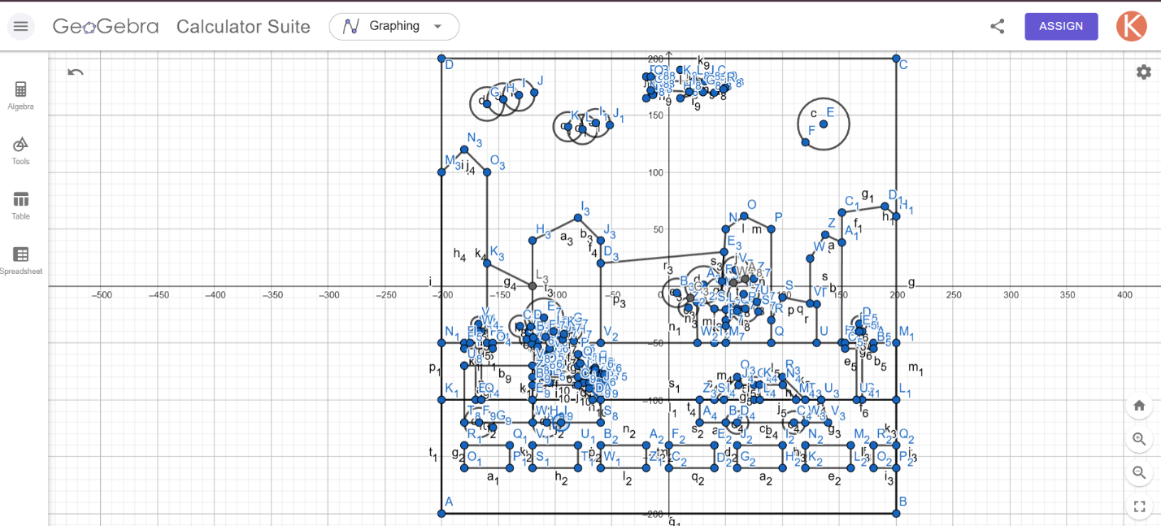

Figure : Scene 1 – Summer in Town

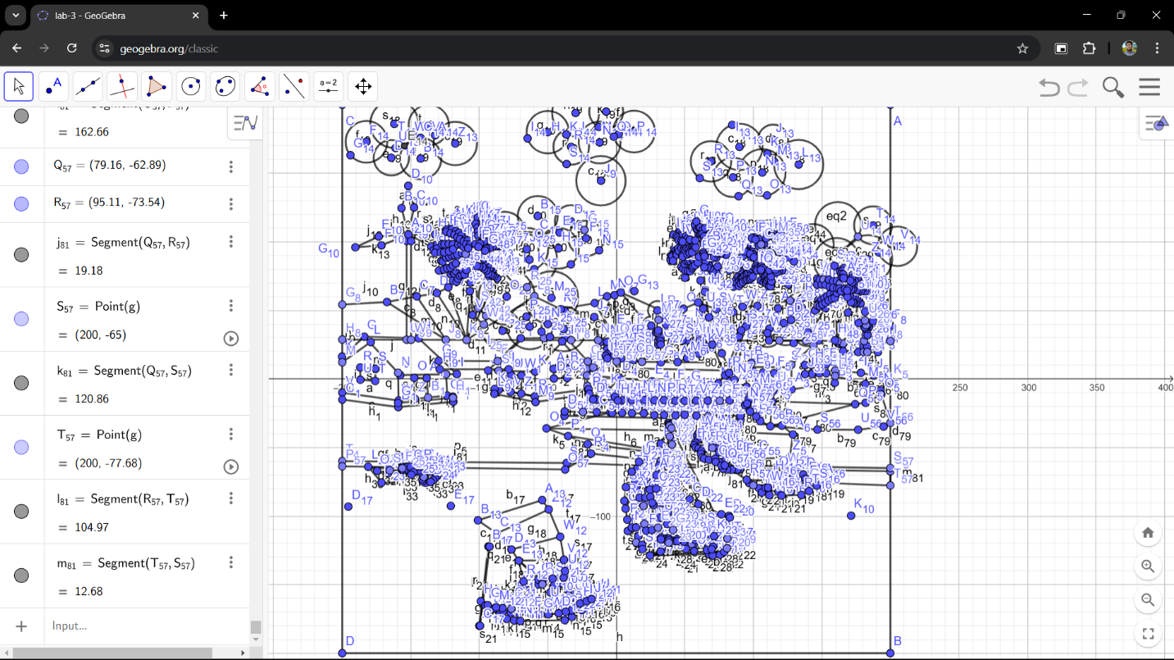

Figure : Scene 2 - Rainy Season in Rural Area

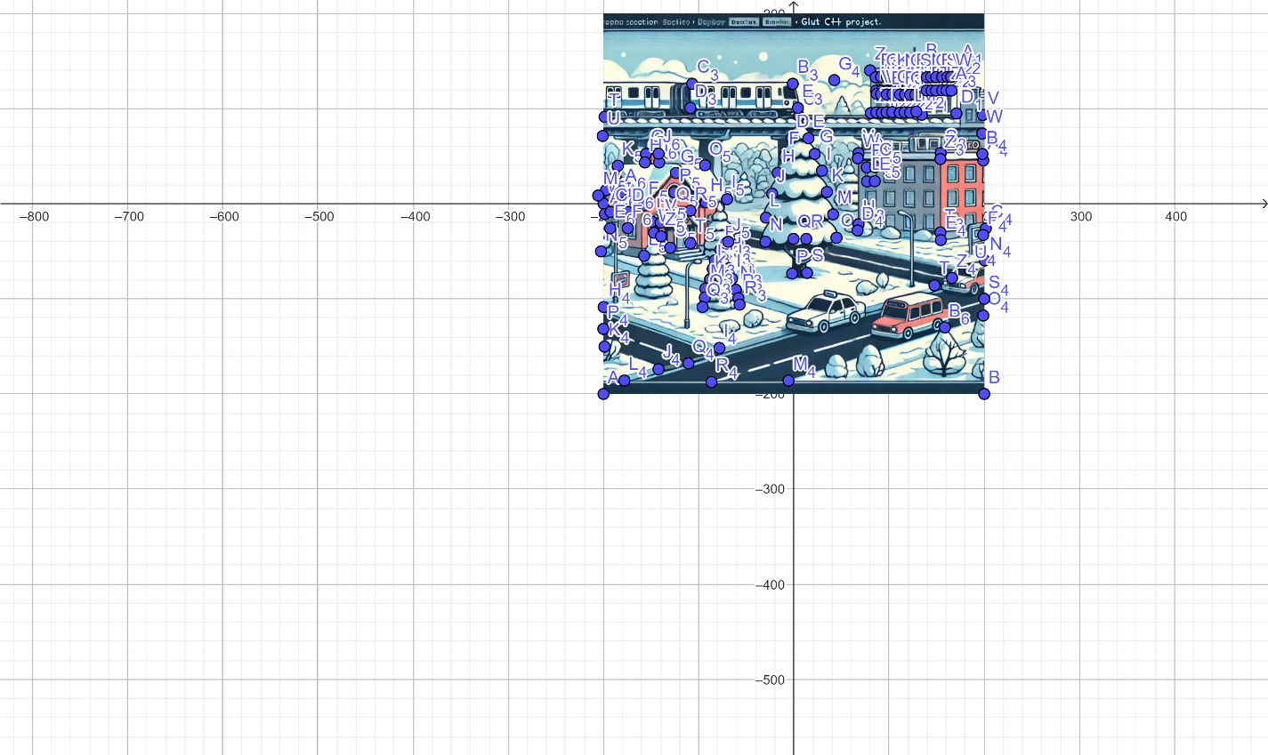

Figure : Scene 3 - Winter in Town

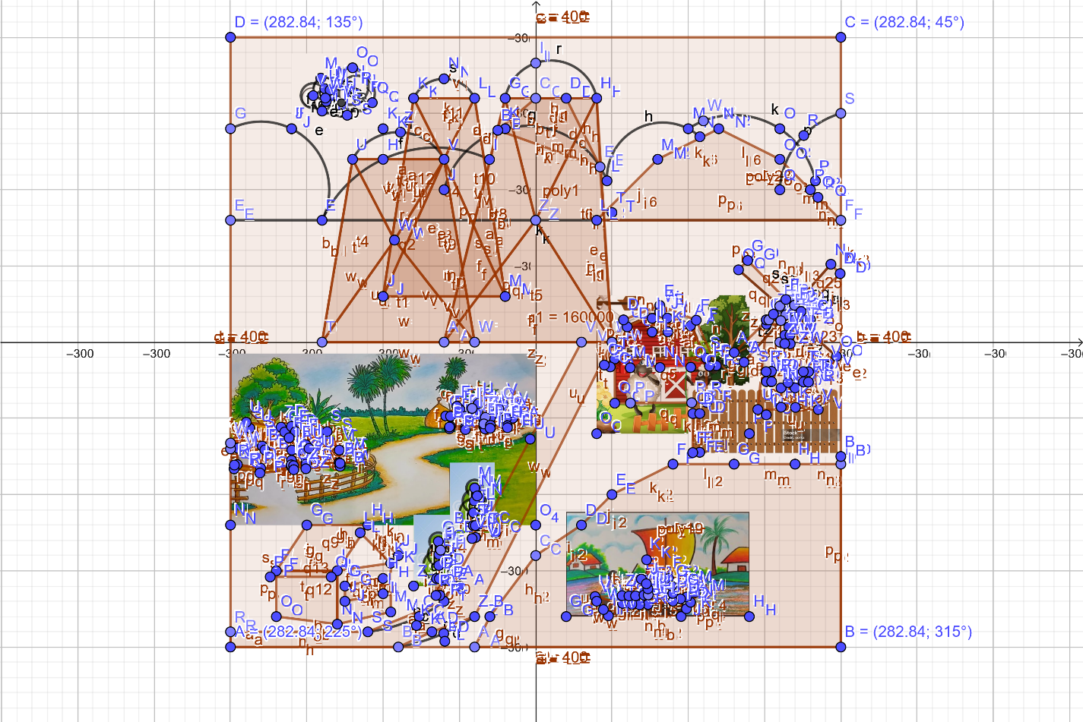

Figure : Scene 4 - Winter in Rurual Area

**Object ID**

|  |  |  |  |
| --- | --- | --- | --- |
| **SL#** | **Member Name / Scene** | **Object ID** | **Object Name** |
| 1 | Scene 1  Name: KANIZ FARIA AHMED  ID: 22-46429-1 SL#12 | O101 | Bushes |
| 2 | O102 | Flowers above the bushes |
| 3 | O103 | Greenery above the road |
| 4 | O104 | Road(pitch) |
| 5 | O105-O111 | White blocks on the pitch |
| 6 | O106-O119 | Buildings |
| 7 | O120 | Sun |
| 8 | O121-O123 | Trees on the greenary |
| 9 | O124-O125 | Clouds on the sky |
| 10 | O126 | Aeroplane |
| 11 | O127 | Car |
| 12 | O128 | Truck |
| 13 | O129-O130 | Road lights |
| 14 | O131 | Bench on the greenary |
| 15 | Scene 2  Name: MEHERAJ HASAN  ID: 22-49363-3  SL#38 | O201 | Sky |
| 16 | O202 | Field |
| 17 | O203 | Sun |
| 18 | O204 | Moon |
| 19 | O205 | Rain |
| 20 | O206 – O2011 | Huts (1-6) |
| 21 | O212 | Windmill |
| 22 | O213 | Ripple Effect |
| 23 | O214 | River |
| 24 | O215 – O219 | Mountains (1-5) |
| 25 | O220 – O223 | Boats (1-4) |
| 26 | O224 – O228 | Clouds (1-5) |
| 27 | O229 | Stars |
| 28 | O230 – O233 | Trees (1-4) |
| 29 | O234-O37 | Coconut Trees (1-4) |
| 30 | O238 | Fireflies |
| 31 | O239 | Lightning Flash |
| 32 | O240 | Bridge |
| 33 | O241 | Stones |
| 34 | O242 | Roads |
| 35 | O243 | Flood |
| 36 | Scene 3  Name: KAZI MAHFUZUR RAHMAN  ID: 22-47384-2 SL#23 | O301 | sky |
| 37 | O303 | Big tree |
| 38 | O304 – O312 | Distance tree |
| 39 | O303 | Moon at night scene |
| 40 | 0313-316 | Small tree |
| 41 | O317 | Train Road |
| 42 | O318 | Building behind train road |
| 43 | O319 | Modern Building |
| 44 | O320 | Old building |
| 45 | O321 | Train Pillar |
| 46 | O322 | Road no 1 |
| 47 | O323 | Road no 2 |
| 48 | O324 | Road no 3 |
| 49 | Scene 4  Name: SHAMS PAHLOWAN SOAD  ID: 22-49342-3 SL#37 |  |  |
| 50 |  |  |
|  |  |  |
|  |  |  |
|  |  |  |
|  |  |  |
|  |  |  |
|  |  |  |
|  |  |  |
|  |  |  |

**Function Name**

|  |  |  |  |
| --- | --- | --- | --- |
| **SL#** | **Member Scene/Name** | **Object Name** | **Function Name** |
| 1 | Scene 1  Name: KANIZ FARIA AHMED  ID: 22-46429-1 SL#12 | Bushes | bushes(void) |
| 2 | Flowers above the bushes | flowers(void) |
| 3 | Greenery above the road | greenery(void) |
| 4 | Road(pitch) | road(void) |
| 5 | White blocks on the pitch | roadBlock1()-roadBlock7() |
| 6 | Buildings | building1()-building8() |
| 7 | Sun | sun(void) |
| 8 | Trees on the greenary | tree1()-tree3() |
| 9 | Clouds on the sky | cloud1()-cloud2() |
| 10 | Aeroplane | aeroplane(void) |
| 11 | Car | car(void) |
| 12 | Truck | truck(void) |
| 13 | Road lights | roadLight()-roadLight2() |
| 14 | Bench on the greenary | bench(void) |
| 15 | Scene 2  Name: MEHERAJ HASAN  ID: 22-49363-3  SL#38 | Sky | drawSky() |
| 16 | Field | drawField() |
| 17 | Sun | drawSun() |
| 18 | Moon | drawMoon() |
| 19 | Rain | drawRain() |
| 20 | Huts (1-6) | drawHut1() – drawHut6() |
| 21 | Windmill | drawWindMill() |
| 22 | Ripple Effect | drawRipple(float x, float y, float radius, float alpha) |
| 23 | River | drawRiver(); |
| 24 | Mountains (1-5) | drawMountain1() – drawMountain5() |
| 25 | Boats (1-4) | drawBoat1() – drawBoat4() |
| 26 | Clouds (1-5) | drawCloud1() – drawCloud5() |
| 27 | Stars | drawStars() |
| 28 | Trees (1-4) | drawTree1() – drawTree4() |
| 29 | Coconut Trees (1-4) | drawCococnutTree1() – drawCoconutTree4() |
| 30 | Fireflies | drawFireflies() |
| 31 | Lightning Flash | drawLightningFlash() |
| 32 | Bridge | drawBridge() |
| 33 | Stones | drawStones() |
| 34 | Roads | drawRoads() |
| 35 | Flood | drawFlood() |
| 36 | Scene 3  Name: KAZI MAHFUZUR RAHMAN  ID: 22-47384-2 SL#23 | sky | Sky() |
| 37 | Big tree | Bigtree() |
| 38 | Distance tree | disTree() - disTree8() |
| 39 | Moon at night scene | drawMoon() |
| 40 | Small tree | SmallTree1()-SmallTree4() |
| 41 | Train Road | drawTrainRoad() |
| 42 | Building behind train road | Building1() |
| 43 | Modern Building | Building2() |
| 44 | Old building | Building3() |
| 45 | Train Pillar | TrainPillar() |
| 46 | Road no 1 | road1() |
| 47 | Road no 2 | road3() |
| 48 | Road no 3 | road3() |
| 49 | Scene 4  Name: SHAMS PAHLOWAN SOAD  ID: 22-49342-3 SL#37 |  |  |
| 50 |  |  |
|  |  |  |
|  |  |  |
|  |  |  |
|  |  |  |
|  |  |  |
|  |  |  |
|  |  |  |

**Animation ID**

|  |  |  |  |  |
| --- | --- | --- | --- | --- |
| **SL#** | **Member Name / Scene** | **Animation Function ID** | **Animation Function** | **Object/Scene** |
| 1 | Scene 1  Name: KANIZ FARIA AHMED  ID: 22-46429-1  SL#12 | A101 | updateSkyColor(int value) | Updating the sky color for day-night transition(Keyboard int.) |
| 2 | A102 | transitionToDay(void) | Transition from night to day(Keyboard int.) |
| 3 | A103 | transitionToNight(void) | Transition from day to night(Keyboard int.) |
| 4 | A104 | updateSunPosition(int value) | Rotation of sun |
| 5 | A105 | updateCloudPosition(int value) | Moving clouds across the sky |
| 6 | A106 | updateAeroplanePosition(int value) | Moving aeroplane across the sky |
| 7 | A107 | updateCarPosition(int value) | Moving car across the road |
| 8 | A108 | updateTruckPosition(int value) | Moving truck across the road |
| 9 | A109 | isPointInsideRoadLight(float x, float y, float lightX, float lightY, float radius) | Turning the road lights on/off through a click of mouse(Mouse int.) |
| 10 | Scene 2  Name: MEHERAJ HASAN  ID: 22-49363-3  SL#38 | A201 | updateSunMoon(int value) | Sun and moon transitions |
| 11 | A202 | updateRain(int value) | Controls the rainfall |
| 12 | A203 | updateWindMill(int value) | Controls the rotation of windmill |
| 13 | A204 | updateRipples(int value) | Controls ripple effects in river during rain |
| 14 | A205 | updateBoatType1(int value) | Controls boat1 movement |
| 15 | A206 | updateBoatType2(int value) | Controls boat2 movement |
| 16 | A207 | updateClouds(int value) | Controls the movement of cloud1 – cloud5 |
| 17 | A208 | updateFireflies(int value) | Controls fireflies movement during non-rainy night |
| 18 | A209 | updateLightningFlash(int value) | Controls lightning flash effect while raining |
| 19 | A210 | updateFlood(int value) | Controls flood level up/down animation |
| 20 | Scene 3  Name: KAZI MAHFUZUR RAHMAN  ID: 22-47384-2  SL#23 | A301 | Clouds() | Clouds moves |
| 21 | A302 | Drawsun() | Sun moves |
| 22 | A310, A311 | Traffic1(),Traffic2() | Traffic Light (change Red, Yellow, and Blue according to Keyboard) |
| 23 | A303 | drawMovingTrain() | Train move left to right |
| 24 | A306 | moveCar1() | Car move |
| 25 | A307, A308, A309 | lamp1(),lamp2(),lamp3() | Main road light  (mouse intereaction) |
| 26 | A312 | drawSnow(int value) | Press S for snow and middle button of mouse to stop snow |
| 27 | A313 | daynight(bool value) | Press D for day scene , N for night scene. |
|  | Scene 4  Name: SHAMS PAHLOWAN SOAD  ID: 22-49342-3 SL#37 |  |  |  |
|  |  |  |  |
|  |  |  |  |
|  |  |  |  |
|  |  |  |  |

**Contribution Chart**

|  |  |  |  |  |  |
| --- | --- | --- | --- | --- | --- |
| **SL#** | **Member Name** | **Implemented Scene** | **Implemented Functions** | **Implemented Animation Function** | **Percentage of Contribution** |
| 12 | KANIZ FARIA AHMED | Scene 1 | bushes(void)  flowers(void)  greenery(void)  road(void)  roadBlock1()-roadBlock7()  building1()-building8()  sun(void)  tree1()-tree3()  cloud1()-cloud2()  aeroplane(void)  car(void)  truck(void)  roadLight()-roadLight2()  bench(void) | updateSkyColor(int value)  transitionToDay(void)  transitionToNight(void)  updateSunPosition(int value)  updateCloudPosition(int value)  updateAeroplanePosition(int value)  updateCarPosition(int value)  updateTruckPosition(int value)  isPointInsideRoadLight(float x, float y, float lightX, float lightY, float radius)  updateSkyColor(int value) | 25% |
| 38 | MEHERAJ HASAN | Scene 2 | drawSky()  drawField()  drawSun()  drawMoon()  drawRain()  drawHut1() – drawHut6()  drawWindMill()  drawRipple(float x, float y, float radius, float alpha)  drawRiver();  drawMountain1() – drawMountain5()  drawBoat1() – drawBoat4()  drawCloud1() – drawCloud5()  drawStars()  drawTree1() – drawTree4()  drawCococnutTree1() – drawCoconutTree4()  drawFireflies()  drawLightningFlash()  drawBridge()  drawStones()  drawRoads()  drawFlood() | updateSunMoon(int value)  updateRain(int value)  updateWindMill(int value)  updateRipples(int value)  updateBoatType1(int value)  updateBoatType2(int value)  updateClouds(int value)  updateFireflies(int value)  updateLightningFlash(int value)  updateFlood(int value) | 25% |
| 23 | KAZI MAHFUZUR RAHMAN | Scene 3 | Sky()  Bigtree()  disTree() - disTree8()  drawMoon()  SmallTree1()-SmallTree4()  drawTrainRoad()  Building1()  Building2()  Building3()  TrainPillar()  road1()  road3()  road3() | Clouds()  Drawsun()  Traffic1(),Traffic2()  drawMovingTrain()  moveCar1()  lamp1(),lamp2(),lamp3()  drawSnow(int value)  daynight(bool value) | 25% |
| 37 | SHAMS PAHLOWAN SOAD | Scene 4 |  |  | 25% |

**Conclusion**

This project effectively showcases the diverse seasonal transitions in Bangladesh, offering a visually engaging and interactive experience. By leveraging OpenGL and C++, it demonstrates the impact of different seasons on urban and rural landscapes. The dynamic animations, realistic transitions, and user interactions enhance immersion, making it both an educational and entertaining tool. Future enhancements could include more advanced weather effects, AI-driven environmental changes, and expanded interactivity. This work serves as a foundation for further exploration into graphical simulations of environmental changes.

**References**

[1] M. Woo, J. Neider, and D. Shreiner, OpenGL Programming Guide: The Official Guide to Learning OpenGL, 8th ed., Boston, MA, USA: Addison-Wesley, 2013.

[2] J. A. Ang, "Introduction to OpenGL," Khronos Group, 2020. [Online]. Available: https://www.khronos.org/opengl/. [Accessed: Feb. 4, 2025].

[3] M. D. Kalin, OpenGL SuperBible: Comprehensive Tutorial and Reference, 6th ed., Upper Saddle River, NJ, USA: Addison-Wesley, 2017.

[4] G. M. Neider, R. E. Davis, and T. A. Woo, OpenGL: A Primer, 2nd ed., Reading, MA, USA: Addison-Wesley, 2006.

***GitHub Repository***

*The complete source code for this project is available at: https://github.com/MeherajHasan/ComputerGraphicsProject*